**Report For Assignment 2**

**2.1**

#1 I opened the txt file by Excel, then save as csv, problem solved.

#2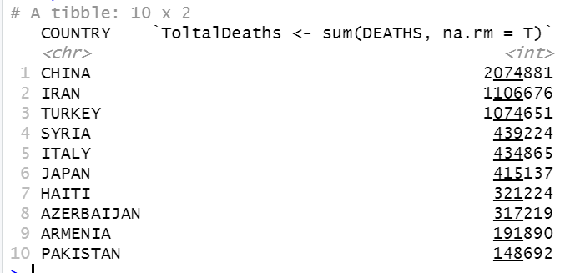

#3

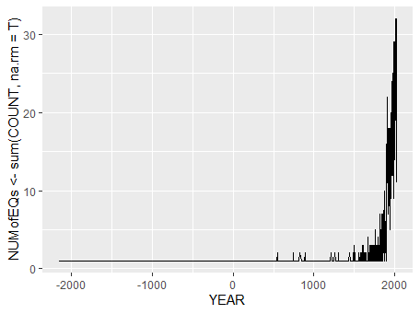

#4

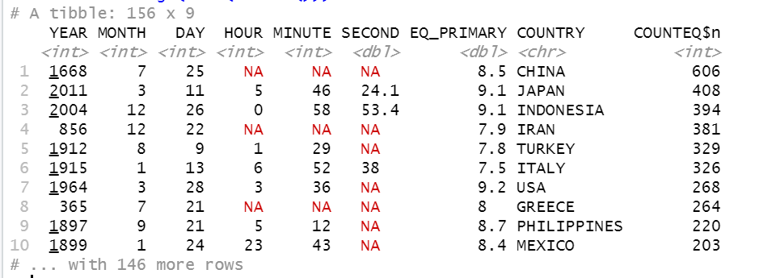

**2.2**

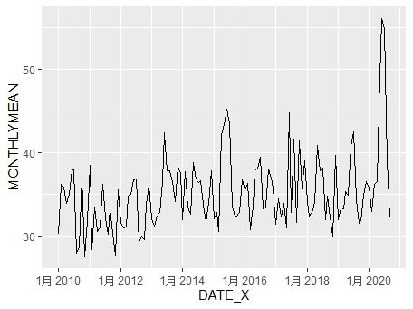

There is a trend in monthly averaged wind speed within the past 10 years. It’s getting much stronger within the past 10 years.

**2.3**

